# IT 230 Coding Activity Submission Template

Submit your work on the coding activities for Modules One, Two, Three, Four, and Six in this document. In addition to this document, you should submit a ZIP file containing all your Visual Studio project files and source code that can be run in Visual Studio on a different computer.

For each coding activity, complete the following steps:

* Download and rename this document to meet the file naming conventions requested in the assignment instructions.
* Fill in the required information below by replacing the bracketed text with the relevant information.
* Submit this document and your ZIP file for grading and feedback. Your ZIP file should follow the same naming conventions.

Document your work in the coding activity by completing each of the following items:

1. Provide a screenshot of the output that resulted from running your program successfully in Visual Studio. See the coding assignment instructions for an example of what should be included in the screenshot. Your screenshot must include the following elements:
   1. Your last name as the first printed text on the screen
   2. Verification that the program is fully functioning and data results are accurate for the given problem

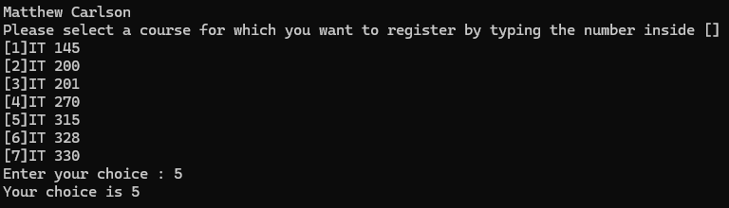

1. Copy and paste the source code text you wrote for this assignment from the *.cs file into the space below. Only providing the *.cs files or a screenshot does not meet the requirements for this part of the assignment. Code should be logically organized. It should also follow proper syntax and conventions noted in the Coding Activity Guidelines and Rubric.

using System;

using System.Collections.Generic;

using System.Linq;

using System.Text;

using System.Threading.Tasks;

namespace DebugFixMethods

{

class Program

{

static void Main(string[] args)

{

(new Program()).run();

}

void run()

{

string choice = "0"; // Changed choice to string and set to 0 as string instead of as int

Console.WriteLine("Matthew Carlson");

WritePrompt();

choice = ReadChoice();

WriteChoice(choice);

}

void WritePrompt() // Fixed function name from 'Writeprompt'

{

Console.WriteLine("Please select a course for which you want to register by typing the number inside []");

Console.WriteLine("[1]IT 145\n[2]IT 200\n[3]IT 201\n[4]IT 270\n[5]IT 315\n[6]IT 328\n[7]IT 330");

Console.Write("Enter your choice : ");

}

string ReadChoice() // Changed signature declaration from int to string

{

string s = "";

s = Console.ReadLine();

return (s);

}

void WriteChoice(string choice) // Declared that arg 'choice' is string

{

Console.WriteLine("Your choice is {0}", choice); // Lower cased 'Choice' to follow arg name

}

}

}

1. Show that you understand the task by explaining the design of your program in the space below. Include the process and steps you took to write your code. Explain how you arrived at the solution to the problem and completed the activity.

For this project it’s not so much designing a program as it is making minor adjustments, but regardless...the simplest explanation is that I followed the program from the top down and slowly picked off coding mistakes and smoothed it out.

As is written in comments, the first note I have is on line 19. There are two ways to solve this: one, the way I did; I changed the variable ‘choice’ to a string so that it could be read more easily by the ReadChoice() function. Or two, which may be the better option in certain circumstances; one could leave it as int and change the ReadChoice() function so that the variable ‘s’ reads an int rather than a string. In a larger program I would absolutely change it into an int so that it is simpler to read and compare regarding both input validation and choice selection, but this did work for the purposes of the project.

On line 28 I fixed the function name for WritePrompt(), which was initially Writeprompt(). This correct capitalization is crucial, especially due to the call made for WritePrompt() on line 22.

On line 35 I changed the signature of ReadChoice() to declare a string, which goes back to my original comment regarding line 19. The main reason I chose to do a string was that ‘s’ was declared as a string, and that was simple to follow.

On line 42 I declared that the arg ‘choice’ was a string, which ties the function in properly with the rest of the program (this is aside from the fact that it was not declared as any type---an arg needs to have a declared type to function at all).

And finally, on line 44 I changed the case of ‘choice’ to lower case from ‘Choice’. This is due to the fact that variables in C# (and most other languages) are case sensitive, and the variable simply *did not work* due to this capitalization.

1. Reflect on your learning experience and what you learned from completing the activity.

This experience was fantastic practice with debugging and finding errors in code. It is very possible that I would make some of these errors, and so it is important to be able to look back at code and find them while debugging. It is also good practice with methods and variables, as this project reinforces proper syntax and naming conventions in C# code.

Beyond that, I don’t have much to reflect on with this project. I greatly enjoy debugging and cleaning up code, and leaving a trail of comments regarding resolved issues always feels nice as well. Completing this activity didn’t exactly teach me anything *new*, but it did reinforce important habits and attention to detail.